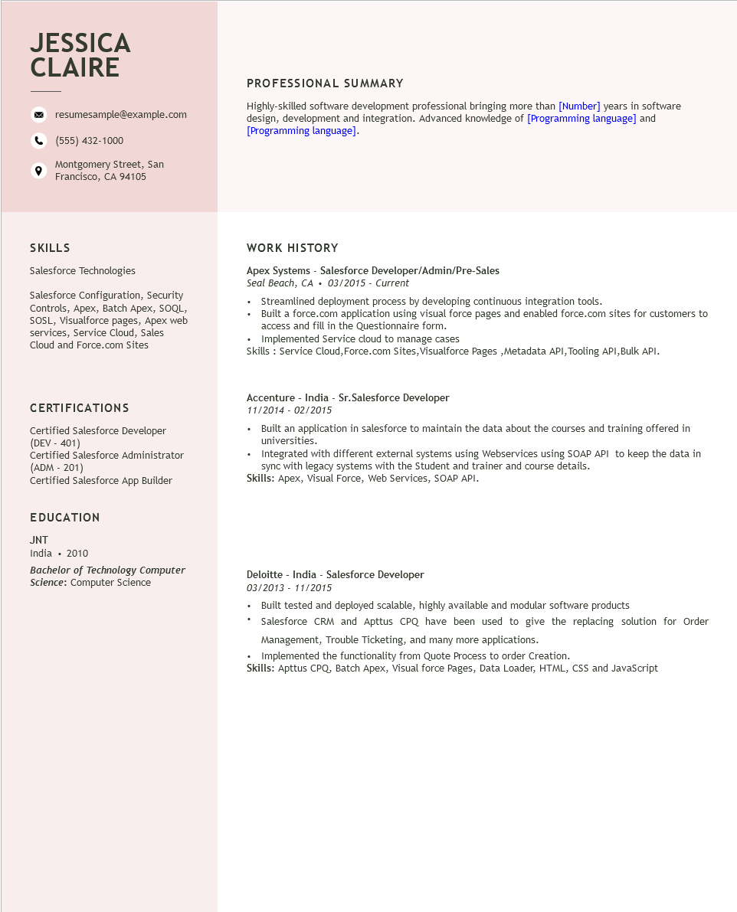
JESSICA CLAIRE
resumesample@example.com
(555) 432-1000
Montgomery Street, San Francisco, CA 94105
PROFESSIONAL SUMMARY
Highly-skilled software development professional bringing more than [Number] years in software design, development and integration. Advanced knowledge of [Programming language] and [Programming language].
SKILLS
Salesforce Technologies
Salesforce Configuration, Security Controls, Apex, Batch Apex, SOQL, SOSL, Visualforce pages, Apex web services, Service Cloud, Sales Cloud and Force.com Sites
WORK HISTORY
Apex Systems - Salesforce Developer/Admin/Pre-Sales
Seal Beach, CA
03/2015 - Current
• Streamlined deployment process by developing continuous integration tools.
• Built a force.com application using visual force pages and enabled force.com sites for customers to access and fill in the Questionnaire form.
• Implemented Service cloud to manage cases
Skills: Service Cloud, Force.com Sites, Visualforce Pages, Metadata API, Tooling API,Bulk API.
CERTIFICATIONS
Certified Salesforce Developer (DEV - 401)
Certified Salesforce Administrator (ADM-201)
Certified Salesforce App Builder
EDUCATION
JNT
India ⚫ 2010
Bachelor of Technology Computer
Science: Computer Science
Accenture - India - Sr.Salesforce Developer
11/2014 - 02/2015
• Built an application in salesforce to maintain the data about the courses and training offered in universities.
• Integrated with different external systems using Webservices using SOAP API to keep the data in sync with legacy systems with the Student and trainer and course details.
Skills: Apex, Visual Force, Web Services, SOAP API.
Deloitte - India - Salesforce Developer
03/2013 - 11/2015
• Built tested and deployed scalable, highly available and modular software products
• Salesforce CRM and Apttus CPQ have been used to give the replacing solution for Order
Management, Trouble Ticketing, and many more applications.
Implemented the functionality from Quote Process to order Creation.
Skills: Apttus CPQ, Batch Apex, Visual force Pages, Data Loader, HTML, CSS and JavaScript

